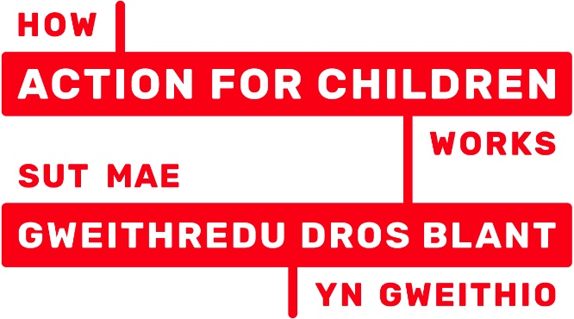

Referral Form: V.2.1 (Feb 2019)
Women and Girls Together Service

Young Person’s Details
Name of Young Person: |  |  |  |  | D.o.B
Address |  |  |  |  | Postcode:
Young Person’s Mobile No. |  |  |  |  | Ethnicity:
Name of School/College or other Education Provision:
Is the Young Person a Young Carer? | Yes  No  Not Known | Is the Young Person Looked After or a Care Leaver? |  |  |  | Yes  No  Not Known
Does the Young Person have a disability or any additional learning needs ? | Yes  No  Not Known | If yes, please specify

Parent/Carer’s Details
Name of Parent/Carer |  | Relationship to Young Person
Mobile: |  | Home Tel No.
Address (If different from young person)

Referrer Details
Name: |  | Role/Title:
Agency:

Address:

Tel No: |  | Email:
Signed: |  | Date:

Please indicate if the young person is currently subject to any of the following plans:-
Child Protection Plan Care and Support Plan Risky Behaviour Plan
SERAF SERAF score: Adult Safeguarding
** Please note that if the young person is subject to a SERAF, and referral to this service is part of the SERAF plan, please forward a copy of the SERAF Risk Assessment and current plan along with this referral.

Please detail any agencies known to be currently involved in supporting the young person, such as Social Care, Team Around the Family, CAMHS, Youth Worker Support, Youth Offending Team, School Counsellor, School Nurse, Emotional Wellbeing Service, Gwalia, Hafan Cymru, Choices.
 | Agency | Professional / Practitioner Name | Contact details
1
2
3
4

Risks and Concerns:
Please tick all that apply to the female that you are referring, and provide further details in the Reasons for Referral section below:
Low Confidence/Self Esteem Mental health concerns Self harming behaviour
Suicidal ideation Suicide attempt(s) Recent Bereavement/loss

Domestic Violence (Parents/Carers) Parent/family member experiences sexual violence
Parental Mental Health Concerns Parental Substance Misuse Parent criminality issues

Unhealthy/Abusive Relationship (Young Person) Victim of Sexual Violence
Stalking Repeated STIs/pregnancies/terminations Concerns of substance misuse

Risk of or have been sexually exploited Experiences/concerns of grooming
Concerns/issues with online safety

Involved or associated with gang/youth violence Criminality (Young Person)

Poor school attendance NEET (Not in Education/Employment or Training)
Victim of bullying

Historic social care involvement Current social care involvement
Experienced/concerns of neglect Experienced/concerns of emotional abuse
Experienced/concerns of physical abuse Homeless

Reasons for Referral:
Please outline the reasons for your referral and provide further details around the above presenting risks and concerns that you have identified for the young person.

Consent
It is important that this referral has been discussed with the Young Person and that they have an understanding of the support being offered and a willingness to engage.
Please tick this box to indicate that the young person is aware of this referral.

Parents/Guardian Consent
I _____________________ give my consent to a referral being made to Action for Children for the
Women & Girls Together Project for ________________________ (child/young person).

I understand that the information on this form will be stored on an electronic database, compliant with the DPA (Data Protection Act) and used for the purpose of providing services to this child/young person.

I agree to the information recorded on this form being shared with other projects & organisations who may also be able to provide services.

Signed__________________________________ Date___________________

Young Person Consent ( If Aged 16yrs and over)
I give my consent to a referral being made to the Women and Girls Together Service.
I understand that the information on this form will be stored on an electronic database, compliant with the DPA (Data Protection Act) and used for the purpose of providing services to this child/young person.
I agree to the information recorded on this form being shared with other projects & organisations who may also be able to provide services/support to me.

Signed__________________________________ Date___________________

What happens next?
Send this referral to:
Women and Girls Together Service, Action for Children, Penfynnon, Hawthorn Rise, Haverfordwest SA61 2AX

Email referral to womenandgirls@actionforchildren.org.uk
Telephone enquiries to Lisa or Donna-Marie 01437 761330

One of the team will contact you to confirm receipt of your referral and request any additional information that may be needed. We will discuss next steps for contacting the family/young person and arranging an initial visit.

